Who we are:
We, MosaiX Missional Church is an Asian Australian Church located in Chatswood. We are here to share God’s love and truth as shown through Jesus Christ with everyone by serving our local community and the surrounding suburbs.

What we do:
During the Covid-19 pandemic time, both people’s lives and livelihood have been seriously impacted. We see the need in the community, so we have been supporting local businesses, providing free lunches, free masks and free toilet rolls in order to show our love and care.
On top of this, we know the Covid-19 pandemic also has a serious impact on the studies of high school students. Many high school students may have fallen behind. In order to help those students to keep up with their studies, we are now offering Free on-line tutoring service to students in Year 7 – Year 11 on subjects of Mathematics, General Science and Physics. We hope that through this free service we can help the students in need in our community to have significant improvements in their studies.

How to apply
If you are interested in our Free online tutoring service, please fill in the following registration form and return it to us via email.

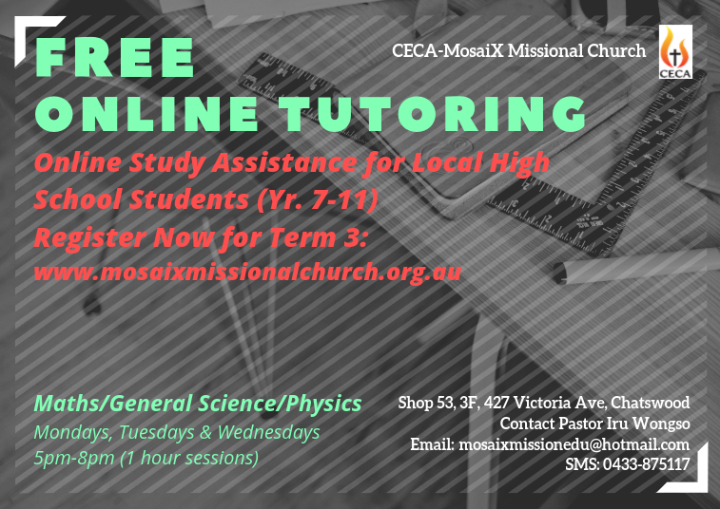

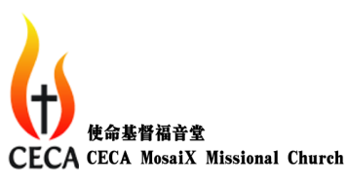
CECA MosaiX Missional Church
Free On-line Tutoring
Registration Form (Term3, 2020)
*Please fill in the information required in the following and return the completed Registration Form to mosaixmissionedu@hotmail.com
Student
Name:
School:
Year:
To Be Enrolled as : □ Regular User □ Casual User (Tick one only)
- Regular User: 2 hours per week throughout Term 3, 2020 (1 hour on Mondays + 1 hour on Wednesdays)
- Casual User: By appointment via phone messaging (1 hour per week on Tuesdays)
Note: An online meeting with the facilitator may be required for the students who would like to be enrolled as a Regular User

Subject: □ Mathematics □ General Science □ Physics
Mobile Phone Number :
Email Address :
Parent/Guardian
Name:
Mobile Phone Number :
Email Address :
Relation to Student :
Please note:
- The “Free On-line Tutoring” service will be provided via ZOOM®. One to One.
- Completion and returning of this registration form does not guarantee success in enrolment
- CECA MosaiX Missional Church reserves the right of ceasing provision of the “Free On-line Tutoring” service to the general public and/or individual students anytime
- Information collected in this form will only be used for communication with students and their parent/guardian regarding the “Free On-line Tutoring” service and for administrative purposes within the “Free On-line Tutoring” service.

